**Software detailed design**

**Model: SmartSONO MS-09**

**Document No. : Q5-29-028(04) Rev.4**

This document valid from the date of approval

|  |  |  |  |  |
| --- | --- | --- | --- | --- |
|  | Title | Name | Date | Signature |
| Prepared by | Researcher | H.W Jung | 2015.05.28 |  |
| Reviewed by | Director | J.H. Oh | 2015.05.28 |  |
| Approved by | CTO | G.Y. Kim | 2015.05.28 |  |

|  |
| --- |
| **META BIOMED CO., LTD.** |

**Revision History**

|  |  |  |  |
| --- | --- | --- | --- |
| Date | Revision | Description | Author |
| 2014.10.30 | 0 | 초기 문서 작업 | 정현우 |
| 2015.02.05 | 1 | SRS 수정으로 인하여 디자인 변경 | 정현우 |
| 2015.03.05 | 2 | 프린터 추가로 인하여 디자인 변경 | 정현우 |
| 2015.05.15 | 3 | 오타 수정 | 정현우 |
| 2015.05.28 | 4 | 오타 수정 및 내용 추가 | 정현우 |

[1 Software Design Specification (SDS) 1](#_Toc422754791)

[1.1 TGC 11](#_Toc422754792)

[1.2 Envelop Detection 11](#_Toc422754793)

[1.3 Dynamic Range 11](#_Toc422754794)

[1.4 Digital Scan Conversion 12](#_Toc422754795)

[1.5 Demodulation 13](#_Toc422754796)

[1.6 Excitation signal 14](#_Toc422754797)

[1.7 Tx 14](#_Toc422754798)

[1.8 Rx 14](#_Toc422754799)

[1.9 Delay Calc 15](#_Toc422754800)

# Software Design Specification (SDS)

|  |  |  |  |  |
| --- | --- | --- | --- | --- |
| Clause | Function | Design Spec | Class | Remark |
| Microprocessor | Initialization | -Create following objects :  HW control / Scan UI /Image Viewer / DB manager | CMainSystem | SDS-M01 |
| -Connect to scan process  (Normal control channel/ real time channel).  -Send Initialization message to scan process  -Check DB status ( size, amount of records, any errors ) | CMRHwCtrl  CAIMsgManager  CAIMsgManagerRT  CPatientDatabase | SDS-M02 |
| -Check Ultrasound HW & display error message.  -Reset Ultrasound HW.( RF Amp ) | CMRHwCtrl | SDS-M03 |
| Probe Setting | First. Probe setting | Probe\_s() | SDS-M04 |
| System option setting | -Supported categories for system options: Scan/Pre-scan/Image processing/DB/System info.  -Save setup information to local file | CSystemOptionsDlg | SDS-M05 |
| Memory device | Patient Information | -Display patient call message  - Blink the message so that it can be noticeable easily | CMainSystem | SDS-D01 |
| Save Cline Loop | -Support flexible format to Include reconstructed image / DB information / raw data  (See below. Database Module) | ::SaveDBDataToFile  ::WriteDataToMIFFile | SDS-D02 |
| Save Image | -Independent Image reconstruction  -Support extensible post processing interface | CScanSeries | SDS-D03 |
| -Import or export images in the DICOM/bitmap format. | CImageViewerCtrl | SDS-D04 |
| Sensors | Probe ID Selection | First. Probe Selection Mode | Mode\_s() | SDS-S01 |
| Probe Selection | Linear Probe Selection | Mode\_Ls()  Probe\_m()  Cconf\_L()  Ddef\_L() | SDS-S02 |
| Convex Probe Selection | Mode\_Ls()  Probe\_m()  Cconf\_C()  Ddef\_C() | SDS-S03 |
| Phased Probe Selection | Mode\_Ls()  Probe\_m()  Cconf\_P()  Ddef\_P() | SDS-S04 |
| Sector Probe Selection | Mode\_Ls  Probe\_m  Cconf\_S  Ddef\_S | SDS-S05 |
| Vaginal Probe Selection | Mode\_Ls  Probe\_m  Cconf\_V  Ddef\_V | SDS-S06 |
| Energy sources | Tx | Synthesize real and imaginary signals | Pulse | SDS-E01 |
| Control phase of RF waveform | CalculateOffsetPhase() | SDS-E02 |
| Output the gating signal which controls the On/Off of RF amplifier | Pulse() | SDS-E03 |
| Control the modulator | ChangeTuningFrequency()  ChangeInterploationFrequency()  ChangeOutputScale() | SDS- E04 |
| Rx | Generate ADC waveform | Pulse() | SDS- E05 |
| Process ADC interrupt | WaitForADCIRQ() | SDS- E06 |
| Control the demodulator | InitDownConverter() | SDS- E07 |
| Control the FIFO | Pulse\_F() | SDS- E08 |
| Process multi-channel input | Pulse() | SDS- E09 |
| Process mater clock | IRQ() | SDS- E10 |
| Range gate | Confirm the option (HW) | Crg\_hw() | SDS- E11 |
| Confirm the option (SW) | Crg\_sw() | SDS- E12 |
| Control the gate | Cgt\_c() | SDS- E13 |
| Control the PRI | Cgt\_PRI() | SDS- E14 |
| Focus Delay | Focus delay for Rx | Fd\_Rx() | SDS- E15 |
| Focus delay for Tx | Fd\_Tx() | SDS- E16 |
| Focus delay for RF Data | Fd\_RF() | SDS- E17 |
| Channel Acq | -Create /Delete/Copy series while scanning  -Reserve series for next scan | CTaskScanDlg  CTaskScanSeriesDlg  CScanSeries | SDS- E18 |
| -Create/delete/ modify parameters  -Import/export parameters in the text format  -Check parameter limit & display error message. | CPara  CSlab  CTaskScanPlanDlg  CTaskScanPlanParaDlg  CTaskScanPlanSlabDlg | SDS- E19 |
| -Support 2 or above localizer planes.  -Function for slice arrangement / copy / paste  -Using DICOM coordinate | CLocalizerWnd | SDS- E20 |
| -Copy/save/remove/modification protocol information  -Import/export protocol parameters. | CProtoDBBrowserDlg | SDS- E21 |
| -Scan load / start / stop  -Setting to the center frequency  -Automatic secondary backup in case of ending scan. | CTaskScanDlg | SDS- E22 |
| Frequency | Control the center frequency | ChangeTuningFrequency() | SDS- E23 |
| Safety features | MI | Calculation MI | Calc\_MI() | SDS-S01 |
| TI | Calculation TI | Calc\_TI() | SDS-S02 |
| Communications | Power On/Off | System check to the Power status. If User want Power off, It can Power off. | Find\_P() | SDS-C01 |
| Freeze | If User check to the Image at pause, It can pause it. | Freez\_c() | SDS-C02 |
| Vertical | If User want to change the image position, It can change position. (Vertical) | Cg\_Ver() | SDS-C03 |
| Horizontal | If User want to change the image position, It can change position. (Horizontal) | Cg\_Hor() | SDS-C04 |
| Dynamic Range | Signal compensate to TGC, DR and TOF | Dy\_TGC()  Dy\_DR() | SDS-C05 |
| Patient Input | -Create New patient  -Import existing patient/study information from local DB / Work list server  -Check mandatory information | CPatientStudyRegDlg | SDS-C06 |
| Focus# | - Check to the Focus Position  - If User want Focus number, It have a 3 focus. | Time\_Focus()  Delay\_Focus() | SDS-C07 |
| Zoom | Zoom motion | Zoom() | SDS-C08 |
| Mode Selection (B mode, M mode, CMF mode, PDI mode) | To the Mode selection for your preferences. | Select\_M()  Select\_B()  Select\_CMF()  Select\_PDI() | SDS-C09 |
| External equipment | DICOM | As External option, It can connect to the DICOM. | Co\_D() | SDS-X01 |
| External Printer | As External option, It can connect others printer | Ext\_P() | SDS-X02 |
| Imaging Processing and Motion (H/W) | Demodulator | Demodulation is the act of extracting the original information-bearing signal from a modulated carrier wave. | DeM() | SDS-PH01 |
| Clutter Filter & Hilbert | Data acquired with a clutter rejection (blood wall, organ…) filter is applied to remove high amplitude, low frequency clutter echoes from the Doppler signal, and prior to spectral estimation of blood velocities. | Calc\_Filter()  Calc\_Hil() | SDS-PH02 |
| ADC | Analogue Digital Conversion | ADC() | SDS-PH03 |

|  |  |  |  |  |
| --- | --- | --- | --- | --- |
| Clause | Function | Design Spec | Class | Remark |
| Interface Requirements | Printers | -Display patient call message  - Blink the message so that it can be noticeable easily | CMainSystem | SDS-I01 |
| Monitors | - It passes through the PC board. | Th\_mT()  Con\_mT()  Con\_mT() | SDS-I02 |
| Keyboard | It passes which key was inputted to the PC board. | Ck\_kB()  In\_kB()  Con\_kB() | SDS-I03 |
| Mouse | It passes which mouse was inputted to the PC board. | Ck\_M()  In\_M()  Con\_M() | SDS-I04 |
| Functions for checking DB size & compaction DB | Software Version Up Checking | Ver\_chec() | SDS-I05 |
| USB | It passes which usb was inputted to the PC board. | Ck\_USB()  In\_USB()  Con\_USB() | SDS-I06 |
| LAN | Used to connect with the outside | Cnt\_Lan  Rc\_Lan  Tl\_Lan | SDS-I07 |
| VGA | To use a dual-monitor | VGA\_C  CGA\_T | SDS-I08 |
| CP | Provided for User's convenience | OPC\_CP  Con\_CP  Tran\_CP | SDS-I09 |
| TGC | TGC: Check to the Gain | TGC\_G  TGC\_T | SDS-I10 |

|  |  |  |  |  |
| --- | --- | --- | --- | --- |
| Clause | Function | Design Spec | Class | Remark |
| Timing and memory requirements | Memory Storage | Save to the information.  (Patient, Image, Cine etc…) | STime\_F()  SCon\_F()  Timefor() | SDS-MS01 |
| System boot time | System boot time | Boot\_S  Con\_S | SDS-MS02 |
| Probe recognition time | Probe is connected to the system time | Probe\_S  Con\_P | SDS-MS03 |
| Probe selection time | Time: a user to select a Probe | PS\_S  Con\_PS | SDS-MS04 |
| Print Output Time | Time printer output | Pr\_S  Con\_Pr | SDS-MS05 |

|  |  |  |  |  |
| --- | --- | --- | --- | --- |
| Clause | Function | Design Spec | Class | Remark |
| Imaging Processing and Motion (S/W) | DAS | Delay And Sum : RF Data rearrangement | DAS\_f() | SDS-PS01 |
| Envelop Detection | After DAS, Envelop Detection Operate  (ABS -> Low Pass Filter) | Envelop() | SDS-PS02 |
| Log Compression | The core transform supports streamed compression. It is extended with an adaptation of our word replacement transform for additional improvement of compression ratio. The transform algorithm has low computational requirements. | Log() | SDS-PS03 |
| Distal Scan Conversion | Digital Scan Conversion | DSC() | SDS-PS04 |
| Base Line | It is mainly used to increase the scope of Doppler bloodstream velocity and reduce confusion of spectral direction | BL\_Op()  Con\_Op() | SDS-PS05 |
| Body Mark | It represents an identification tag on the screen. | Bd\_M | SDS-PS06 |

## TGC

Attenuation [ $dB]$ = Biological attenuation [ $dB/cm∙MHz]$ $×$ Depth [ $cm]$ $×$ Frequency [$MHz]$

## Envelop Detection

|  |
| --- |
| B\_env = zeros(data\_total,N\_sc);  for i=1:N\_sc  tmp = Result\_Suming\_Delay(:,i);  tmp1 = abs(hilbert(tmp));  B\_env(:,i) = tmp1;  end |

## Dynamic Range

$$y=\left\{\begin{aligned}255∙\left(\frac{20}{DR}∙\log_{10}\left(\frac{x}{x_{max}}\right)+1\right) for {10}^{-\frac{DR}{20}}≤\frac{x}{x_{max}}≤1 \\ 0 for\frac{x}{x_{max}}<{10}^{-\frac{DR}{20}}\end{aligned}\right.$$

|  |
| --- |
| for a=1:data\_total  for b=1:N\_sc  if (new\_env(a,b) < 10^(-dB/20))  new\_env(a,b) = 0;  else  new\_env(a,b) = 255\*((20/dB)\*log10(new\_env(a,b))+1);  end  end  end |

## Digital Scan Conversion

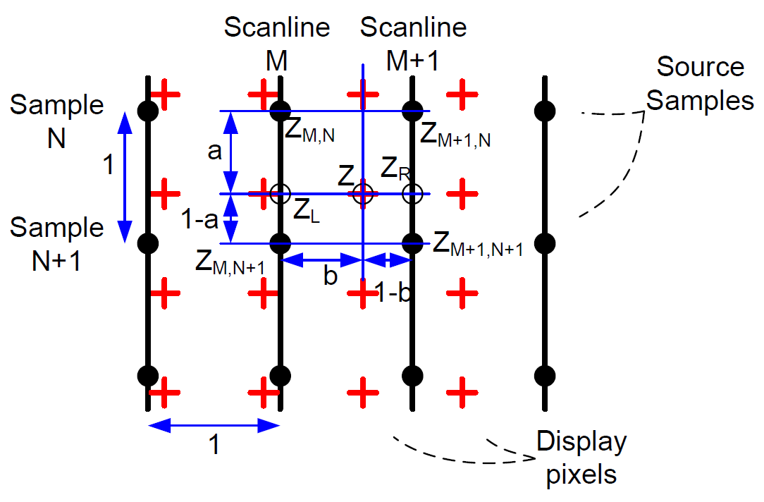

Sample: N

Scanline: M

Source: (N,M), (N+1,M)…….

$Z=a∙b∙Z_{M+1,N+1}+\left(1-a\right)∙b∙Z_{M+1,N}+a∙\left(1-b\right)∙Z_{M,N+1}+(1-a)∙(1-b)∙Z_{M,N}$

|  |
| --- |
| for i=1:img\_x  ix = i\*dx;  for j=1:img\_z  iz = j\*dz;    z = iz/pixel\_d;  x = ix/sc\_d;    z\_L = floor(z);  z\_H = z\_L+1;  x\_L = floor(x);  x\_H = x\_L+1;    z\_err = z-z\_L;  x\_err = x-x\_L;    if((z\_L>0) && (z\_H <= data\_total) && (x\_L > 0) &&(x\_H <= N\_sc))  Zon = new\_env(z\_L,x\_L);  Zon1 = new\_env(z\_H,x\_L);  Zin = new\_env(z\_L,x\_H);  Zin1 = new\_env(z\_H,x\_H);    Zri = Zin\*(1-z\_err) + Zin1\*z\_err;  Zro = Zon\*(1-z\_err) + Zon1\*z\_err;  Z = Zro\*(1-x\_err) + Zri\*x\_err;    B\_img(j,i) = Z;  end  end  end |

## Demodulation

|  |
| --- |
| CW Oscillator: s\_0 (t)=cos(2πf\_0 t)  Doppler Shift Frequency: s\_1 (t)=Acos(2π(f\_0+f\_d )t+∅)  Out Product: s\_2 (t)=A/2 cos(2πf\_d t-∅)+A/2 cos(2π(2f\_0+f\_d )t+∅)  After HPF: s\_3=A/2 cos(2πf\_d t-∅)  s\_3 is Demodulation |

## Excitation signal



The ultrasonic signal that is generated in transmission.

## Tx

**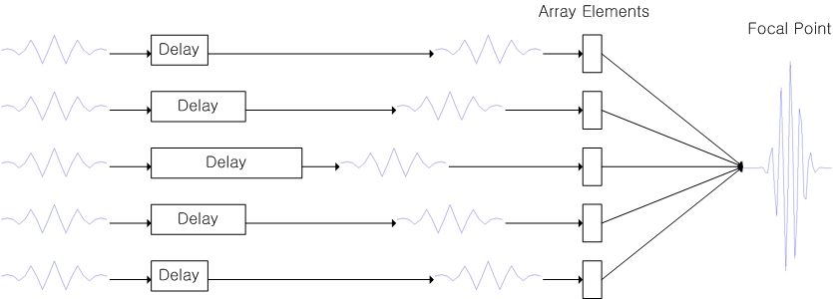**

Signal processing process for a transmission

## Rx

**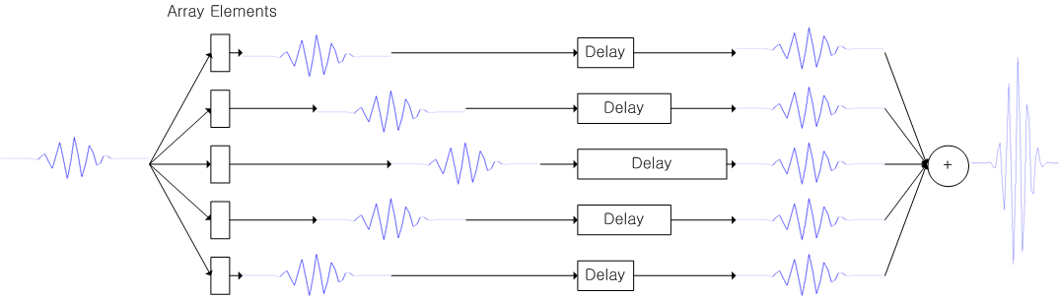**

Signal processing on reception

## E:\Work\현우-논문준비과정\Re_Data\Target_1\wave_Channel.jpgDelay Calc

**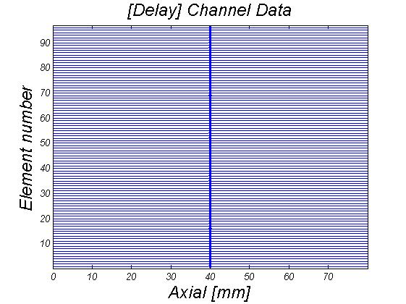**

* 1. **Adsf**

**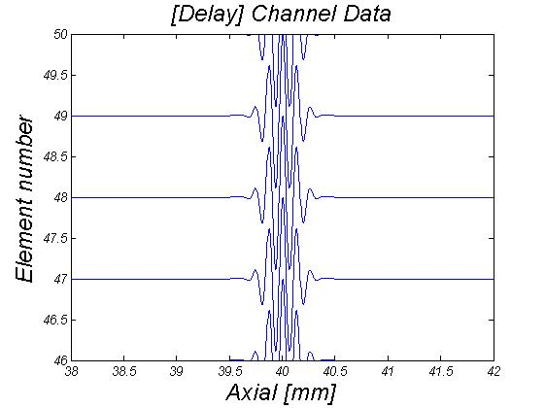**

Signal processing on delay